3.20: a) If air resistance is to be ignored, the components of acceleration are 0 horizontally and 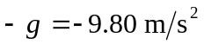 vertically.
b) The x-component of velocity is constant at 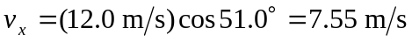. The y-component is 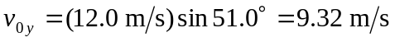 at release and when the shot hits.
c) 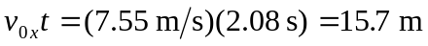.
d) The initial and final heights are not the same.
e) With 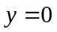 and v_{0y} as found above, solving Eq. (3.18) for 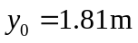.

f)
